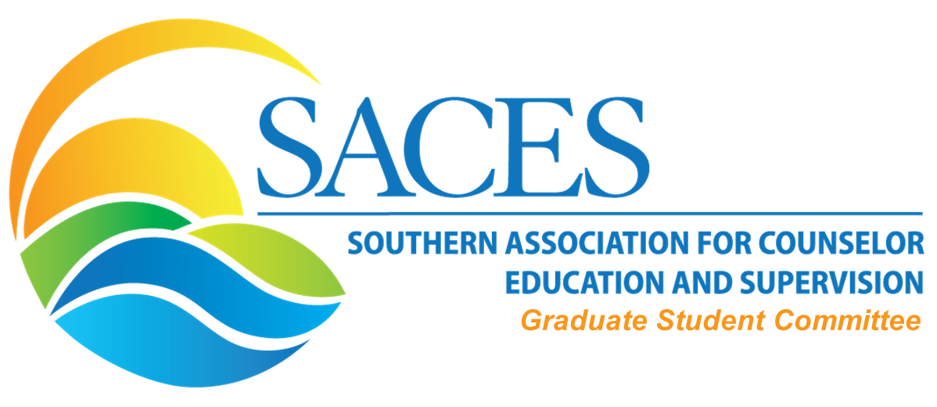

Minutes

Committee members present: Raven Cokley, TJ Schoonover, Ann Gregory, Marcella Rolle, Ron Eastes, Jennifer, Perry, Hannah Coyt
Meeting Date: September 20, 2019 2-3 PM (CST)

  - Old Business
  - Reports/updates from each workgroup
      - Blog Workgroup
        - Working on blog for September will focus on interview with ACES GSR, Joey Tapia-Fuselier
        - Active people: 4-6
      - Interviews Workgroup
        - Have interviews, but must be edited; will set up a meeting
      - Newsletter Workgroup
        - Haven’t met for a while; follow up with Joey
      - Collaboration with Interest Networks Workgroup
        - Needs? Supports?
      - Social Media
        - No one present
      - Hannah will follow up with all workgroups after ACES conference to assist with integration of goals/objectives of the GS committee.
- Involvement (Application Process)-Continued work on this area
  - Discuss commitment/needs
    - limiting 6 people per work group and the rest being moved to work with the interest network with lower level of commitment.
- ACES Student Lounge in Seattle (Friday, October 11, 2019 from 10:30 am-12:00 pm)
  - Link to the flyer
    - Call for panelists has gone out
      - Received several emails of interest/will be following up with them by the beginning of next week
- Timeline
  - Next Meeting - October; doodle poll will go out
  - Submitting application (google form)-November (after ACES)
- New Business
  - SACES EC approved Graduate Student Interest Network
    - Call for interested participants will go out after ACES Conference

Committee Co-Chair: Hannah M. Coyt
Email: grad.rep@saces.org

Committee Co-Chair: Jose “Joey” Tapia-Fuselier
Email: grad.rep@saces.org

Link to the September meeting: The meeting was unable to be recorded this month. We will continue recording at next month’s meeting.

