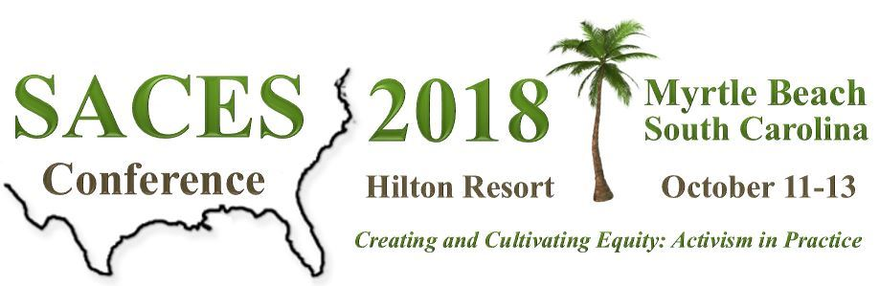
Overall Conference and
Session Evaluation Tracking Form

Conference CE Evaluations will be online during and after the conference; completion of the Overall Conference Evaluation and a Session Evaluation Form for EACH session you attended are required to receive credit for completed hours. You must have a completed registration and attend the conference to be eligible for CE credit. Upon completion of the online surveys, you will receive access to your CE Certificate in the online CE portal (visit saces.org/CE for link).
This tracking form is available to help you remember the details and ratings for each of your sessions. Only content and round table sessions are eligible for CE credit; poster sessions or other meetings are not eligible. A maximum of 21 CE credits are available (6 Thu; 7 Fri; 8 Sat). All sessions are 1 CE hour unless otherwise noted. Sessions designated for Ethics and Supervision CEs are indicated in the conference program and will automatically be identified on your CE certificate. All CE Evaluation Surveys must be completed by October 30, 2018 to receive NBCC approved Continuing Education Hours. For additional information on the CE process, please contact Michael Jones at msjones@messiah.edu.
Overall Conference Evaluation Tracking Form
On a scale from 1 (very unsatisfactory) to 5 (very satisfactory), how would you rate or answer the following?
Conference organization |  |  | What other topics would you like SACES to cover at future conferences or webinars?
Registration
Preconference Sessions
Career Connection Events
Sponsors / Exhibitors |  |  | What did you find most useful or helpful at the conference?
Opening Reception (Thu)
Awards Luncheon (Fri)
President’s Reception (Fri)
Friday Night Social |  |  | What did you find least useful in the conference? (Please indicate any comments and suggestions for improvement)
Boxed lunch (Sat)
Hotel venue & facilities
Conference website
Conference program |  |  | Additional comments or suggestions?
Conference app
Overall relevance of topics to your work
Overall satisfaction with the conference

Session Evaluation Tracking Form
On a scale from 1 (very unsatisfactory) to 5 (very satisfactory), how would you rate each session?
Day & Time  (Oct 11-13, 2018) | Program ID # | Program Name | The trainer demonstrated good knowledge of the training content. | The trainer demonstrated good presentation skills. | The trainer engaged the participants and was open to questions. | This training met the objective as identified in the program agenda. | This training was well organized. | The content was delivered in a clear and understandable manner. | The training provided useful and/or new information relevant to my work. | I would recommend this training to others. (yes/Maybe /No) | I would recommend this training for the SACES webinar series (Y/M/N) | Comments
Th 8^{30am} |  | Preconf (3cr):
Th 1^{pm} |  | Preconf (3cr):
Fr 8^{am}
Fr 9^{am}
Fr 10^{am}
Fr 11^{am}
Fr 2^{pm}
Fr 3^{pm}
Fr 4^{pm}
Sa 8^{am}
Sa 9^{am}
Sa 10^{am}
Sa 11^{am}
Sa 1^{pm}
Sa 2^{pm}
Sa 3^{pm}
Sa 4^{pm}

